Name: __________________________________ Date: ______________ Period: _______
The Lorax
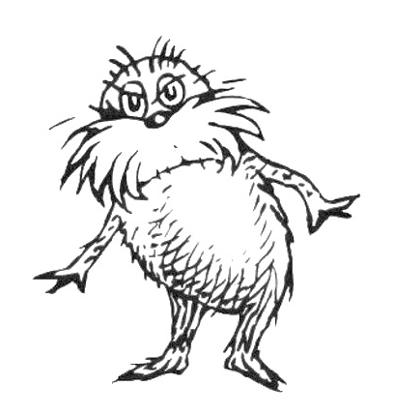

DIRECTIONS: As you watch the movie you will take notes here. As you are taking notes think about this content question: How can renewable resources become nonrenewable? When the movie is over you will do the exercise on the back.

What is the material resource that is being used in the movie?
________________________________________________________________________________________________________________________________________________________
What is the name of the product that is being made with that material resource?
________________________________________________________________________________________________________________________________________________________
When the Oncler first begins producing Thneeds, are the Truffula trees a renewable resource?
____________________________________________________________________________
____________________________________________________________________________
How is the environment when Oncler first comes to the valley?
____________________________________________________________________________
____________________________________________________________________________
What other natural resources are hurt when the Oncler is producing Thneeds?
____________________________________________________________________________
____________________________________________________________________________
____________________________________________________________________________
____________________________________________________________________________
How is the environment when Oncler's Family goes away?
____________________________________________________________________________
____________________________________________________________________________
At the end of the movie are the Truffula trees a renewable resource?
____________________________________________________________________________
____________________________________________________________________________
How can you help to make Truffula trees a renewable resource again?
____________________________________________________________________________
____________________________________________________________________________

Thesis: The Lorax is about how renewable resources like trees can become nonrenewable.

Supporting Evidence A:

Supporting Evidence B:

Supporting Evidence C:

Concluding Sentence:

Directions: In the space below write a paragraph using the evidence you have found to support your answer to our content question: How can renewable resources become nonrenewable?

____________________________________________________________________________
____________________________________________________________________________
____________________________________________________________________________
____________________________________________________________________________
____________________________________________________________________________
____________________________________________________________________________
____________________________________________________________________________
____________________________________________________________________________
____________________________________________________________________________
____________________________________________________________________________
____________________________________________________________________________
____________________________________________________________________________
____________________________________________________________________________
____________________________________________________________________________
____________________________________________________________________________
____________________________________________________________________________
____________________________________________________________________________

